**Lexar® Professional CFexpress™ Type B Card GOLD Series**

2TB

1TB

512GB

256GB

128GB

[Where to buy](https://americas.lexar.com/product/lexar-professional-cfexpress-type-b-card-gold-series/)

**Key Features:**

**Up to 1900MB/s read, 1500MB/s write speeds**

**Sustained write speeds of 1300MB/s**

* Next-Generation Performance
* Seamless Video Capture
* XQD Compatibility
* For Professional Users

**Key Features:**

**Up to 1900MB/s read, 1500MB/s write speeds**

**Sustained write speeds of 1300MB/s**

* Next-Generation Performance
* Seamless Video Capture
* XQD Compatibility
* For Professional Users

**Key Features:**

**Up to 1900MB/s read, 1500MB/s write speeds**

* Next-Generation Performance
* Seamless Video Capture
* XQD Compatibility
* For Professional Users

**Key Features:**

**Up to 1900MB/s read, 1500MB/s write speeds**

* Next-Generation Performance
* Seamless Video Capture
* XQD Compatibility
* For Professional Users

**Key Features:**

**Up to 1900MB/s read, 1500MB/s write speeds**

* Next-Generation Performance
* Seamless Video Capture
* XQD Compatibility
* For Professional Users

[Features](https://americas.lexar.com/product/lexar-professional-cfexpress-type-b-card-gold-series/#feature-section)[Specifications](https://americas.lexar.com/product/lexar-professional-cfexpress-type-b-card-gold-series/#specifications)[Part Numbers](https://americas.lexar.com/product/lexar-professional-cfexpress-type-b-card-gold-series/#product-numbers)[Related products](https://americas.lexar.com/product/lexar-professional-cfexpress-type-b-card-gold-series/#related-products)

**Features**

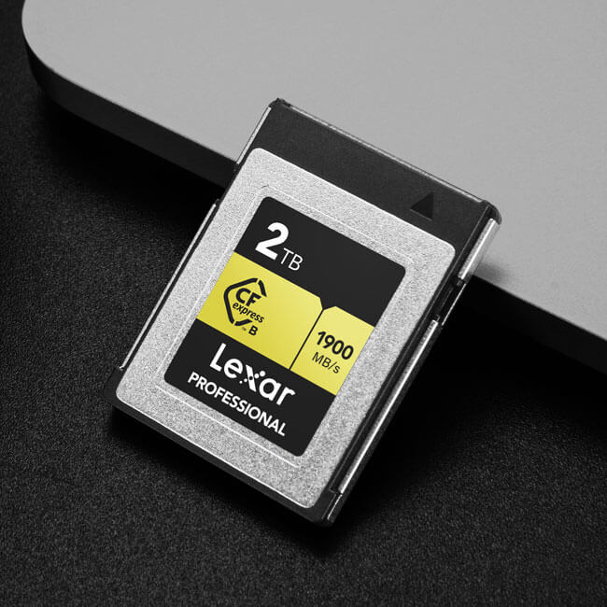

**Blazing-fast performance to capture cinema-quality 8K RAW video**

The Lexar® Professional CFexpress™ Type B Card GOLD Series features blazing-fast performance to capture cinema-quality video with speeds up to 1900MB/s1 read and up to 1500MB/s1 write. With minimum sustained write speeds of 1300MB/s1, this card enables seamless video recording from start to finish.

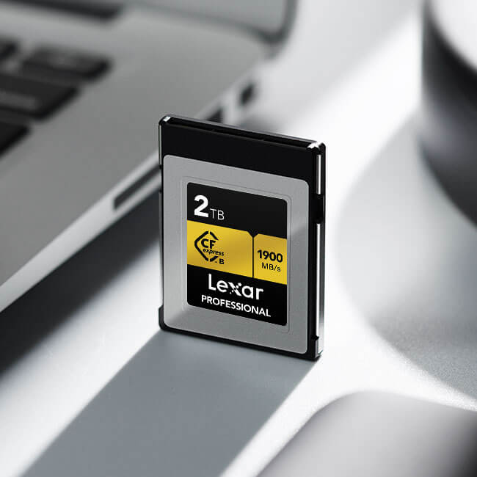

**Sustained speeds for professional video capture**

For professional videographers looking to get the most out of their cameras, the Lexar® Professional CFexpress™ Type B Card GOLD Series provides minimum sustained write speeds of 1300MB/s1 allowing you to capture cinema-quality video without dropping frames.

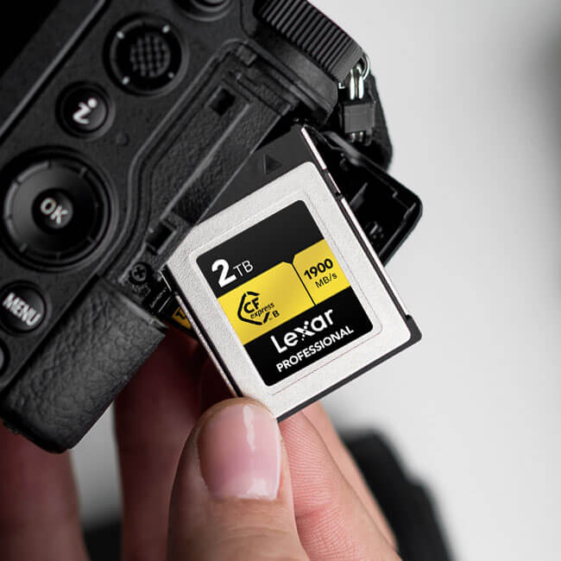

**Limited lifetime warranty**

All Lexar® Professional line memory cards come with a limited lifetime warranty3 and are backed by expert technical support.

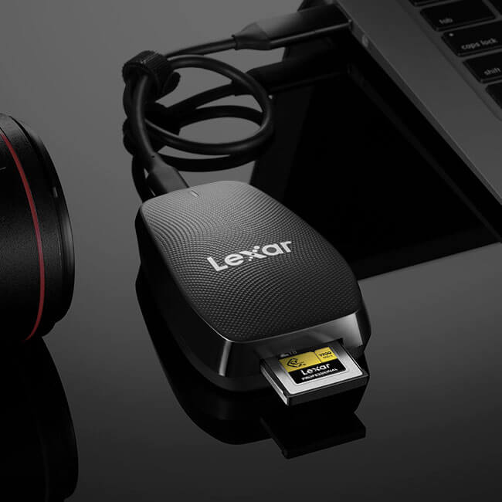

**Save time with a dramatically accelerated workflow**

With the blazing-fast performance of the Lexar® Professional CFexpress™ Type B Card GOLD Series, capture and transfer files quickly and efficiently. And when paired with the Lexar® Professional CFexpress™ Type B USB 3.2 Gen2x2 Reader (sold separately), maximize your workflow and productivity from start to finish, so you can save time and get back to business.



**Rugged durability for epic adventures**

Whether you’re chasing sunsets, waterfalls, or any other adventure, the Lexar® Professional CFexpress™ Type B Card GOLD Series features rugged durability for added protection against the elements including extreme temperatures, shock, and vibration2.

**Rigorously Tested**

All Lexar products undergo extensive testing in the Lexar Quality Labs, facilities with thousands of different cameras and digital devices to ensure performance, quality, compatibility, and reliability.

**Specifications**

* Capacity

2TB | 1TB | 512GB | 256GB | 128GB

* Form Factor

CFexpress™ Type B

* Interface

PCIe Gen3x2

* Performance

Up to 1900MB/s read, 1500MB/s write speeds1

* Sustained Write Speed

1300MB/s¹ (1TB and 2TB only)

* Operating Temperature

-10°C to 70°C (14°F to 158°F)

* Storage Temperature

-25°C to 85°C (-13°F to 185°F)

* Dimension (L x W x H)

29.60 x 38.50 x 3.80 mm / 1.16” x 1.51” x 0.14”

* Weight

7.65 g / 0.016 lbs

* Warranty

Limited lifetime warranty3